The Whitchurch-on-Thames 2019 Village Plan – Draft (v04)

Contents
Introduction 2
Action summary and what you can do 2
About the village – History 3
The 2009 Village Plan 5
Village Plan 2018 Survey – Summary of Results 7
Traffic and Parking 8
Congestion, Parking and Road Safety 8
Proposals 9
Community Buildings 11
Pavilion Plan 12
Village Hall Plan 13
Open Spaces & Environment 13
Emergency Plan 15
Flood Risk Mitigation 15
Community 16
Village Societies 16
Community Support 16
Sport 16
River Access 16
Other Activities 17
For Young People 17
Appendix 1: Action Plan with dates and responsibilities 18
Appendix 3: Open Spaces & Habitats Guidelines 21
Appendix 4 2009 Village Plan – Action Plan Progress – as of June 2018 22

Introduction

The Parish Council felt it was time to update the previous 2009 village plan and so set up an independent group which has reviewed the previous plan, conducted a survey of residents’ views and gathered information on traffic and a wide range of other issues to create this updated plan.
At this stage the plan is a draft and we are still seeking feedback and further ideas.

Action summary and what you can do

We live in a lively and attractive village in beautiful countryside and the key message from the survey is that residents want the public areas to be maintained to a higher standard. The three biggest challenges identified are to build a new sports pavilion on the Village Green, to rejuvenate the Village Hall and implement a plan to improve road safety and traffic flows.

Summary of Action Plan
- Impose parking restrictions to improve traffic flow
- Impose a 20mph limit and other road safety measures
- Replace the Pavilion on the Village Green
- Upgrade the Village Hall
- Develop maintenance plans for Open Spaces following best-practice guidelines
- Assist with a Conservation Area Assessment
- Implement a community emergency plan, including volunteers, preparations etc.
- Complete the draft flooding mitigation plan begun after the 2004 floods
- Resurface pavements prioritising by use and condition as funds allow
- A series of minor improvements listed in appendix 1.

A full list of the draft priority actions and recommendations which have been agreed with the Parish Council is in appendix A.
What you can do
- Contribute to fundraising for the Pavilion & Village Hall
- Get/stay involved in the various working groups to complete the above actions
- Join the Community Meal
- Improve habitats (perhaps starting with your garden)
- Support church, pubs, and village societies
- Join the green team to look after our open spaces
- Let us have your views and additional ideas on this plan

Historically many people have been involved in village life and it is hoped that this plan will encourage even more people to get involved and will provide a focus for their activities. At the kick-off meeting for the village plan, the view of the volunteers was that they wanted to get on with useful activities at the same time as writing the plan. As a result some of the key actions are well underway however more support is now needed.

About the village – History

The river was the reason for early settlements here. A 2,500 year old Iron Age Hillfort strategically overlooks a bend in the Thames. Later, the river frontage was where the current village began to be developed. There are accounts of a very active quayside roughly along the line of the present Mill Drive from which agricultural produce and other goods were loaded. The few remaining cottages facing the quayside (including a former pub and laundry) are perhaps the oldest building sites of the village. By the time of the Domesday Book they had been joined by one of the largest water mills on the river and the original wooden church. The name Whitchurch comes from the Saxon Hwitcurke.
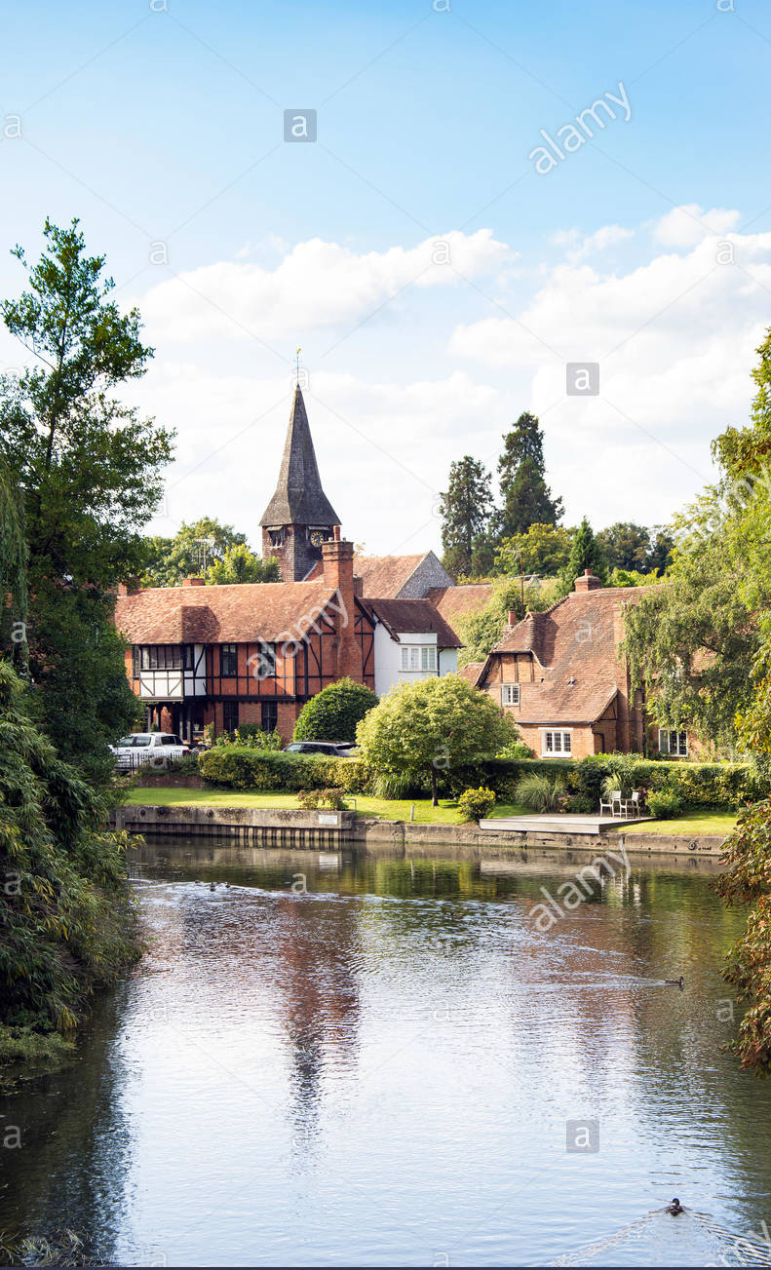
The buildings of the Royal Manor of Whitchurch, hidden behind the quayside frontage, were almost certainly a stopping point for the Royal Court progressing by river towards Oxford. Edward II appears to have been a regular visitor. After the demolition of the Royal Manor buildings, three major classical structures came to dominate the scene: Walliscote House (built in part over the footings of the Manor buildings), The Old Rectory and Thames Bank. There are 23 Grade II listed buildings along the High Street including smaller cottages dating from the 16 th to the 18 th century.
In 1792, a number of local landowners and gentry decided to build the toll bridge and, in 1840, the Pangbourne Station opened.
In 1858, Henry Woodyer oversaw the substantial rebuilding of the church on earlier foundations and re-using of earlier features. In the words of Richard Hughes, Rector of Whitchurch, 1979 – 2000, "The whole has mellowed with the centuries nevertheless, so that the casual visitor will find a typical country church in which nothing, it seems, is too out of place." In fact this observation on the church could be applied to the village as a whole.
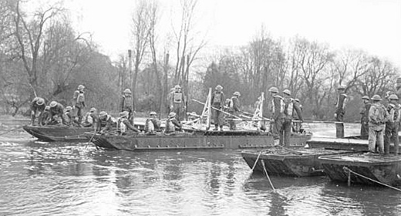
In the Second World War, accommodation was built for Canadian servicemen training for D-Day in what is now Manor Road. They donated the building (their shower block) which is now the Village Hall. Polish and other exiles also came to the village and built a church. (See below for plans for the Village Hall and the Polish Church Memorial gardens which will include plaques explaining these events.) From the 1940s, village families also moved into Manor Road.

During the 1960s and 1970s, big houses were divided and there was a spate of private development in the Hardwick Road area. The village continues to expand gradually, as the section below on demographics mentions.
The Conservation Area
A Conservation Area was defined in the 1970s [check] based on the High Street but extended to include Eastfield House which is a fine red-brick neo-Victorian structure in the 'Waterhouse' style (oddly not listed).
It is a responsibility of South Oxfordshire District Council to write a Conservation Area Assessment but this has never been done for Whitchurch-on-Thames. It is recommended that the community now works with the District Council so as to record what it is that we value in the village. As well as non-listed building (such as Eastfield House and the two pubs), features such as the brick and flint walls, grass verges etc. give the village its pleasant rural feel; something many survey respondents have said they want to retain.
[• Add more on the Conservation Area Assessment (Inc. list of key assets Appendix 5) (JB)]
The Wider Parish
Within the wider Parish boundary there are an extra 10 or so listed buildings including Hardwick Stud, The Baulk, Pilgrim Cottages and Hardwick House. Henry James stayed at Hardwick House and it features in his novel The Portrait of a Lady. Later, the enthusiasm of a new owner of the estate for racehorses, fast cars and real tennis is believed to have inspired Kenneth Grahame’s The Wind in the Willows.
The parish is in the Chilterns Area of Outstanding Natural Beauty. It contains 6 local wildlife sites and borders Hartslock Nature Reserve, one of seven internationally designated Special Areas of Conservation (SAC) in Oxfordshire and noted for its Monkey Orchids. Other habitats include chalk grassland (supporting a specialised range of plants and fauna), woodland, river banks and meadows. In the Hardwick Haymeadows, 190 different plant species have been recorded.
The Thames Path takes a little detour through the village up to the Hartslock Bridleway and groups of walkers are often seen.
About the village - Demographics
Every 10 years, the census records the population and gives breakdowns by age, occupation, etc. For the parish of Whitchurch, the population was 824 in 2011 - up 9% from 731 in 2001. (We believe this rate of growth continues.)
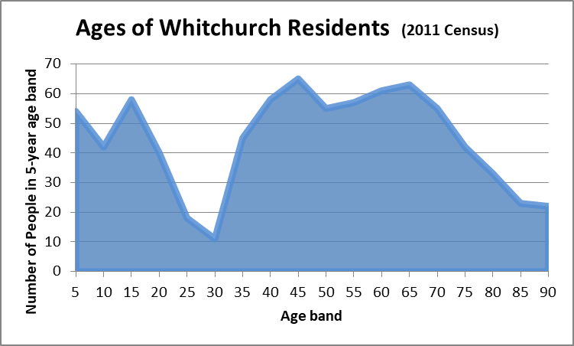
From the census data, we can see the age profile (i.e. how many people there are in each age band) and this tells a story: people move in to the village in their 30s; their children may go the preschool and primary school but, after secondary school, leave for education or jobs elsewhere. The village has plenty of children but few people in the late twenties and early thirties.
This pattern perhaps emphasises how important the school is to the whole community.

The census data (ref TBA) shows a very wide range of occupations and household arrangements: the population is in some ways more diverse than might be imagined: some are very well-off, others need support.
About 20% of adults have lived in the village for less than 5 years. There are a lot of long-term residents, with over 38% having lived here for over 20 years and some families having been in the village for generations. By the way, the age profile in the previous 2001 census was much the same as in 2011.

Housing Needs
Most people (88% of those who expressed a view in the survey) do not want any major housing development in the village but some would like to see some more affordable housing. In the Oxfordshire Local Plan the policy is to protect Areas of Outstanding Natural Beauty. (Ref TBA. Note: this plan is not approved at the time of writing). A group looked at creating a Neighbourhood Plan for the village but concluded that it would be very difficult to provide truly affordable houses in the parish - the Oxfordshire policy is to spend any levy generated from a new development to provide affordable homes at a cost-effective location in the county and that would not be Whitchurch with its high land prices. We see organic growth continuing but wish this to be done following OCC policy on AONBs, in keeping with the Conservation Area, flood alleviation guidelines and the other policies of the Oxfordshire Plan. (ref map)
Many developments are taking place in South Oxfordshire which will greatly increase traffic (e.g. population in Benson and in Woodcote will grow). Already traffic is the number one concern of the survey respondents.

The 2009 Village Plan

Many people helped to develop and implement the last plan which was felt to have been very successful. Of the 22 proposed actions, 60% have been completed; perhaps the two most beneficial being the transfer of ownership to create the Village Green and improving the village website.
The action to study the feasibility of building a new Village Hall was completed. However the conclusion was that it would be very difficult to fund the creation of a facility large enough to replace the current Village Hall. A related action to make immediate cosmetic upgrades to the existing hall was been partially completed although, for a few years while its future was being considered, no improvements were made. As is described below, this is being remedied.
Some improvement of street lighting and furniture were made, playground equipment was upgraded and a neighbourhood watch scheme extended.
7 of the 22 original actions remain and are picked up in this new plan. Most critically, it has not been easy find the best solutions to improve traffic flow and road safety. Similarly, improving the maintenance of pavements and drains has been difficult (not least because of council funding cuts since 2009) although progress has been made: “the cut” was resurfaced and the condition of drains is being effectively monitored.
For reference, a full list of previous actions and outcomes is in Appendix 4.
One final conclusion from reviewing the plan is that the village has perhaps spent time over the last 10 years in evaluating a wide range of ideas outside the original plan. This plan will attempt to limit the number of activities and also say what should not be done.
As in the last plan, it is recommended that the Parish Council allocates members to oversee specific areas and help the volunteers get the practical actions completed.

Village Plan 2018 Survey – Summary of Results

The Village Plan Committee thanks the 143 people who completed the survey in the summer of 2018. Although this is fewer than answered the last survey in 2008, it seems to be representative (the mix of ages and locations of the respondents matches both the last survey and the latest census data).
The full results are here [add hyperlink] but in summary:
- Traffic - particularly parking and pedestrian safety - is of increasing concern. Respondents would support both a 20mph speed limit (90% approve) and also parking restrictions to stop commuters parking all day on the high street.
- The Parish Council wants to replace the Cricket Pavilion and also improve the Village Hall. 75% of people thought some improvements to the Village Hall were needed. 9 respondents suggested that, rather than improving the hall, we use the proceeds from selling it to build a new facility elsewhere, however this was considered and it is not feasible.
- People are very happy with the Village Green and Maze and appreciate the opportunities both for Cricket and Football, for unstructured play, dog walking and for enjoying being outdoors. 90% of people would like the Maze area to remain an area for picnics and for wildlife. 79% did not want to see further development of the Village Green. Of the 21% who did want some development, many suggested facilities for teenagers, however fewer than 3% of respondents wanted big facilities with permanent hard finishes such as those required for a BMX track or skate park.
- There is a desire for better maintenance of the village environment. 60% are concerned about flash flooding and nearly all want a plan to maintain drainage better so as to reduce the risk. Support for hanging baskets was limited (22% with some comments strongly against) but people want to see verges repaired and more wildflowers and trees planted. Amongst other things, people suggested having a group that would regularly maintain open spaces and footpaths.
- Improved access to the river was supported, if this can be arranged. Several ideas have been suggested including setting up a canoeing club.
- People would like to see improvements to pavements and the highest priority was somehow to make the area outside the Ferryboat safer for pedestrians.
- Additional community activities. Suggestions, such as a monthly community meal and various fitness activities will be followed up. Improving awareness of existing activities is also important.
We believe these items are covered in the recommendation of this plan.

Traffic and Parking

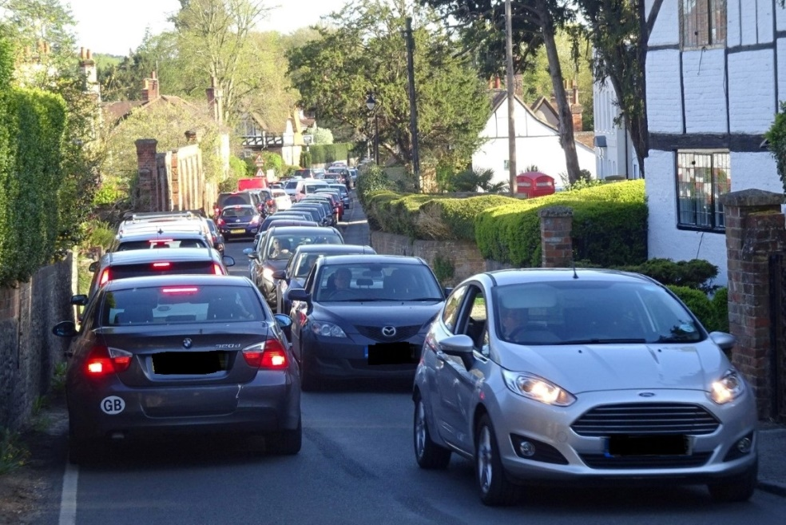

Congestion, Parking and Road Safety

Whitchurch-on-Thames has a few issues we need to address.
At certain times there is a severe congestion problem in the High Street, principally during the morning and evening rush hours. The problem is sometimes exacerbated by the Toll Bridge and the railway bridge in Pangbourne.
Parking is an issue for a number of reasons - parked cars can slow down the traffic but with irregular gaps to allow cars to pass, traffic is unable to flow at peak times. Whilst it may be perceived that, we have plenty of parking in the village; it is not always available to residents when they need it and is poorly disciplined.
Villagers feel that vehicles are travelling too fast through the village and have concerns for safety. Whilst not all cars are speeding, (over the current limit of 30mph) it still feels too fast and pedestrians feel unsafe. In addition, the survey identified that pedestrian safety concerns in two areas: the southern side of the Toll Bridge where the pavement is not very wide and in the narrows by The Ferryboat, where there is no kerb.

Proposals

As part of the previous village plan a transport group, TAPAG, was created. TAPAG has recently been repopulated and reenergised. They have done a traffic study and developed an outline plan, then instructed a consultant to assess the options.
Proposed Changes
Concern | Action | Results
TRAFFIC FLOW | Clear “no parking” sections of consistent lengths in key pinch points (e.g. entrance to narrows and by junctions like Eastfield Lane). | Improved traffic flow and driver behaviour once regular visitors learn the improved organisation of the parking.  Better visibility, so safer for crossing the road.
PARKING | Defined parking bays with restrictions (e.g. Residents only at certain times of the day) | Better parking discipline and stops commuter parking
SAFETY | 20mph speed limit,  Aided by the parking bays creating chicanes.  Consider the option raising the kerb at the ferryboat. | Traffic moves more slowly and predictably
Other | Reinstate the verges (e.g. on the east side of the High Street).  Stop people parking on the grass verges along Manor Road.  Encourage less use of cars – e.g. operate a walking school bus. | Improves the look of the village

Immediate actions to improve pedestrian safety

- The Toll Bridge Company, after exploring some options for widening the pavement but deciding it was impractical until 2028, have introduced a 20 mph speed limit.
- A working party cleared vegetation to make it possible to walk the whole length of Eastfield Lane on the grass verge.
- It is recommended to repaint the badly-faded white line by the Ferryboat so as to clearly demark the pavement.
Next Steps
TAPAG have reviewed our plan with a number of consultants, who think the plan is a good one and will achieve our key objectives. The next stage is to complete a detailed design with one of the consultants who will be able to guide us through the red tape and processes to get a good solution delivered.

Current Thoughts [this will be replaced by the TAPAG consultant’s detailed design when available – possible including a map]
Preference | Pros | Cons
Create two designated blocks for cars to park on the west side of the High Street creating space for several northbound cars to pause allowing southbound flow. The rest of the west side of the High Street to have double yellow lines, this will save additional signage. The first block to be north of Eastfield Lane which should remove one of the bottlenecks by replacing discretionary white lines with double yellow lines. See diagram attached | - Restrict speed outside of peak times  - Aid flow at peak times  - Increase the possibility of disciplined parking  - Improved flow should reduce frustrations and air pollution  - Improve the chances of keeping the High Street clear on programmed street cleaning days | - Cost of yellow lines  - Policing
A mandatory speed limit of 20mph to continue from the Toll Bridge to the narrows above Hardwick Road | - Increase safety  - Improve flow | - Additional signage  - Policing
Residents only parking for one or two set times a day in the designated parking blocks. These restrictions need be no longer than one hour. | - Discourage long term parking which can be all day and all week in some instances.  - Improve flow at peak times as there will be fewer cars parked even in the designated blocks | - Additional Signage  - Residents permits and their management  - Visitors’ permits and their management  - Enforcement/ Policing  - Moving the all day and all week parkers to other parts of the village  - Cost
Reconstitute the verge on the east side of the High Street between Duchess Close and Racquets | - Maintain the structure of the verge  - Prevent further erosion and potholes  - Improve flow by reducing “new” road width  - Improve aesthetics | - Cost of reconstitution and insertion of physical barrier; high kerb or posts
Create a bay for 3-4 cars on east side of High Street north of Racquets and again with residents only parking as above. | - Increase parking opportunities  - Help reduce speed with a physical barrier | - Additional Signage  - Residents & Visitors’ permits and their management  - Enforcement/ Policing  - Moving the all day and all week parkers to other parts of the village  - Cost

Community Buildings

Background & Objectives
Both buildings owned by the Parish Council are in need of repair or replacement. Over the last few years, little work has been done on the Village Hall which is showing its age and it is recognised that the Pavilion is beyond economic repair.
One idea considered was to demolish the Village Hall, develop that land and use the proceeds to build a large combined facility to meet the all requirements, with changing rooms, a large function room (for events like the Art & Crafts Exhibition, classes, etc.), and a suitable kitchen (for events like the Harvest Supper). It turned out that it was not going to be feasible to fund this.
A solution that does meet all the varied requirements and which it is believed can be funded is to keep the buildings separate, designing each to meet its own specific need. The table below summarises the existing buildings, their uses and the recommended actions. (The Old Stables is included for completeness)

Building | Capacity | Uses (Draft: to be confirmed) | Plan
Refurbished  Village Hall | 90 | Community Meetings,  Arts & Crafts Exhibition  Classes, Camera Club  Parties, Music & Theatrical (Stage)  Parish Council meetings  Polling Station | A 3-year refurbishment programme has started (see below)
New Pavilion | 2 teams + supporters | Sport: Cricket Club & Football. Possibly Netball.  School use  Community events, e.g. village fete  Other TBA (recommend define now) | Replace the existing building. This is the top priority in the plan (see below)
Old Stables | 30 | Church Meetings  Art Café + Small groups | The PCC continue to maintain

It is also recommended that:
- competition for funds is avoided by being clear on what the overall plan is with fundraising bodies so they are not feel they are being approached twice for the same objective.
- a joint online facility booking system is set up which can be used for all three facilities
- the PC set up clear responsibilities for the ongoing maintenance of their two buildings as recommended below. Note: the Old Stables is already carefully managed by the parochial church council (PCC).
Volunteers are doing a significant amount of work in this area and, although no one is individually named in this plan, their contribution is nonetheless very highly-valued.

Pavilion Plan

The existing Pavilion and ancillary buildings are substandard and beyond economical repair. Therefore their replacement with more contemporary facilities within a single building is being promoted. The vision is to provide better facilities for existing users, but also to broaden the use to include additional sports and community uses. Effort will be made to encourage local residents to participate, including youth teams with a special emphasis on girls’ teams.
The new facility has been designed with input from the cricket and football clubs and several recently built pavilions have been visited to understand what facilities are needed, the likely costs and how to secure funding.
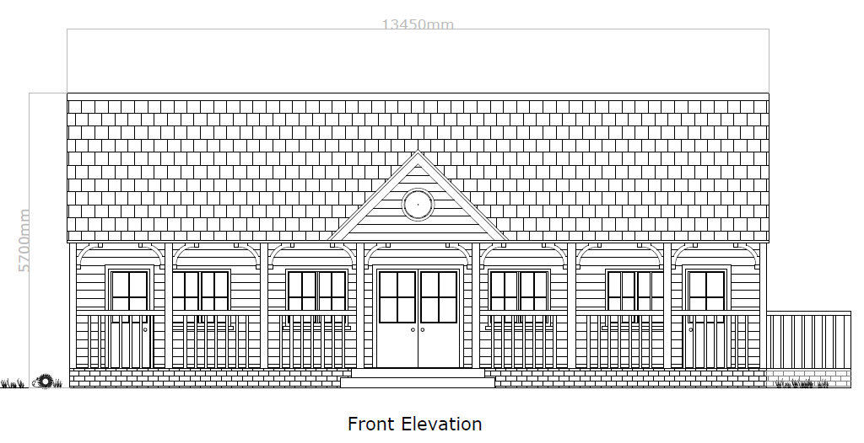The proposed Sports Pavilion has been carefully designed so that it does not detract from existing natural beauty of the Village Green. It is to be positioned in the south east corner to avoid damaging in any way the existing large trees. The design includes a wooden weather boarded exterior, a pitched roof and a clock face to the front elevation. Facilities will include a reasonable sized general purpose room (5m x 6m), two separate changing rooms with toilets and showers and a small kitchen. The building will meet current Accessibility Act requirements.
Planning permission was granted in January 2019. At time of writing, work is progressing to estimate costs in order to promote a major fund raising exercise (target 2019/2020). The Parish Council has agreed to pay for initial pre contract costs, including architects fees.
Although, in the survey well over 50% did support an increase in parish rates (currently £500 pa), it is recommended not to increase the rate and instead encourage village residents to contribute voluntarily. The cricket club itself has committed to raise significant funds but this project will still be the biggest financial challenge for the village for a very long time.
A Pavilion development group is being set up but, once the building is complete, it is recommended responsibility for maintenance is transferred to the existing Village Green working group. This group includes representatives from the cricket & football clubs, as well as the wider village and the parish council. The Parish Council will own the Pavilion and let it out to the Cricket Club and others.

Village Hall Plan

The Village Hall has been looking tired and potential users are driving to more attractive locations outside the village. Both declining revenue and uncertainty over future plans has meant that there was no investment for several years. Work started in 2018 to turn this around and encourage more use by residents and non-resident.
The Village Hall should be the community centre for the village where groups such as the Camera Club meet and larger-scale activities like Pilates classes can be held. As well as providing a better environment for them, an upgraded hall could support other activities. It is hoped that volunteers can be found to organise:
- a monthly community lunch.
- junior and/ or adult amateur drama groups
- music events
A detailed, costed, three-year upgrade plan has been prepared which will make the hall much more attractive. Already the windows have been replaced, the hall painted (thanks to a team from Grant Thornton) and a 100-piece crockery set has been donated. Further planned improvements include:
- Cleaning and repair of the roof, the electrics , sanitary facilities and partition wall
- Upgrade of kitchen (this is the most costly item)
- New flooring
- Install phone & Wi-Fi
- Cosmetic improvement including new stage curtains if funds permit
- check the central heating system and potentially install a new boiler
- Resurface car park and provide better dustbin storage
- New notice boards and meeting material such as flip charts
- Make a board showing the history of the hall from its initial use by the Canadian Air Force.
At the time of writing, fundraising for the next stage has begun and some grants have already been obtained. Again, volunteer and financial support from the village residents will be critical to deliver this plan.
It is hoped that enough additional revenue will be generated to cover running costs. The recently-reformed Village Hall committee needs to be broadened to ensure some coordination between the three community buildings.

Open Spaces & Environment

We want to encourage more use of our open spaces and to maintain them better including improving habitats for wildlife - both flora and fauna. To achieve this, the PC, village groups and others are:
- Agreeing who will be responsible for creating and managing a plan for each of 9 areas which are listed on the next page. The resulting plans will be based on a template used for the Village Green and will include planned improvements as well as the regular maintenance schedule. This link shows the status of all the 9 areas [TBA]. The PC has agreed to review this annually.
- Applying the guidelines shown in the appendix (Do consider these for your own garden!)
- Creating a Green Team. The maintenance of several areas depends on volunteers and we would like to see more support. Already informal working parties but it is proposed to organise this better and hope to involve a wider range of ages in the activities.
Summary of Plan for Open Spaces
- Village Green
  - In the last few years, maintenance guidelines have been agreed (e.g. on grass cutting), trees and hedges planted, the beech hedge cut back.
  - The new Pavilion is discussed above and sport is discussed generally in the community section below. It is not recommended to install other sport equipment such as a basketball hoop. This is following the wishes of 79% of residents who wish to enjoy this beautiful area as it is.
- Maze – We also propose keeping the maze as it is. Thanks to some volunteers, new bricks have recently been added and damaged bricks replaced. There is a clear maintenance plan, although some way of funding brick replacement and adding new bricks for people new to the village is still needed.
- Polish Church Memorial Garden – outline of Polish Church, plaque with wildlife [ask Sally]
- Manor Road Play Area – needs cleaning (fences, sign, equipment) and some repairs. Regular grass cutting and cutting back of vegetation is being done by the council’s contractor but it is recommended to have an ongoing plan yet using volunteers for cleaning, etc.
- Churchyard: Well maintained by the Friends of St Marys and St John.
Paths
- Muddy Lane – sweep in autumn and fill puddles with shingle/scalpings
- Eastfield Lane – verges were tidied to make it easier to walk to school safely. This should be maintained.
- Hardwick Verges – Complete the planned verge restoration and improve the path
- The Cut. This was repaved recently and currently needs no maintenance.
Pavements
- Cost estimates have been obtained for refurbishing pavements (Manor Road, Swanston Field, Hardwick Road £76k – Cost excluding Swanston Field TBA). With other activities this is felt to be a later priority and it is recommended that the Parish Council develop a gradual, phased plan prioritised according to the state of the pavement), cost of the work and usage.
- It is also recommended that the PC investigate grant and other OCC support.
- Encourage walking (The school is working on a plan).

Habitats
We know that many habitats are being lost. For instance, the parish has important grassland habitats but, across Oxfordshire, grassland butterfly numbers have fallen by 30% since 1990 [State of Nature report https://www.wildoxfordshire.org.uk/stateofnature 2017/ ]
Non-native species (such as the Oak Processionary Moth outbreak in Pangbourne), climate change and increasing road traffic add to pressure. Other than the above-mentioned guidelines, this plan contains no specific recommendations. However, the Hardwick Estate is managed with a well-informed emphasis on conservation from which there is much to learn. We have two active societies - PAWs and WoTHABS - also keen to raise awareness.

Emergency Plan
Oxfordshire County council encourage parishes to develop a Community Emergency Plan and a subgroup was formed some of whom attended OCC training. The plan describes risks and responses and provides contact numbers, etc. to help utilities and emergency services coordinate the response. There are still actions to complete before we register the plan with the OCC however the draft plan is here/below (link TBA) Also available is this helpful list [link] of what you can do to prepare for an emergency (such as keeping insurance contact details on your phone).
Remaining actions include:
- Encouraging more volunteers to learn to use the defibrillator in the phone box by the entrance to Manor Road.
- Setting up the Village Hall as a place of refuge.
- Encouraging people who might need help if it snows heavily or there is a power cut to register with Scottish and Southern electricity (please contact John Bradon who can provide a form to register with them).

Flood Risk Mitigation

Two actions are recommended:
- Ensure drains are inspected and issues reported on Fix My Street. Some progress has been made with this but it needs continuing coordination of volunteers by the PC. (Note: Flash flooding is a bigger concern for most people than the river flooding.)
- Complete the flood action list begun with the excellent analysis of the causes of the 2004 flooding of the Greyhound pub and some nearby houses to ensure that the mitigations are completed and continue to be monitored.

Community

Village Societies
Whitchurch has a strong community spirit, which is often given as the reason why residents have moved here and stayed here. The Village Groups section of the website lists the wide and increasing range of societies in the village. The Art Café has been a great success. It is hoped that people will continue to support the existing groups but also that more volunteers may come forward and some possibilities are mentioned below.

Community Support
The Church & School are key institutions at the heart of village life. Although the Village Plan has not identified any new recommendations specific to either institution, they remain critical to the community.

Some thought has been given as to how to provide more contact and support for people who need it. Already, the Pangbourne & District Volunteer Centre provides Whitchurch residents with help with transport. As part of its wide-ranging pastoral support, the church organises the weekly coffee mornings to which everyone is welcome.
It is suggested to set up a monthly Community Meal in the refurbished Village Hall.

Sport
Objective: Support cricket and football. Encourage hard to reach groups such as teenage girls to participate.
As well as the adult mens’ team cricket club has boys and girls junior teams and there is junior football on the Village Green.
Once the Pavilion is upgraded, we would have excellent facilities for a Netball team and a small ad-hoc group is investigating whether this could be set up. (Need to ask the school if a team could use the all-weather court).
The survey showed support for tennis but in a small village it would be very hard to get enough people to keep a tennis club going. It is a short walk to the Pangbourne tennis club who themselves are in need of more members. Also, just over the bridge are the Pangbourne Bowls Club and, for canoeing, the Dolphin Centre. For rowing, the excellent Goring Gap boat club have just moved from Sheepwash Lane in the parish to a new facility near Lower Basildon.
At Village Hall Pilates, Tap dancing and fitness classes are available. Village Walks are organised twice a year and the Henley and Goring Ramblers is one of many local walking groups. There are also running groups and informal cycling groups.

River Access
The survey showed a desire for more access to the Thames on the Whitchurch side. Some options were explored with various riparian landowners but with no success yet. For now, the best options seem to be:
- Continue to use the facilities on the Pangbourne side including the slipway by the surgery
- Improve the slipway by the toll house and the public steps further along Mill Drive. A number of improvements have been identifies and should be implemented by the Parish Council. Like the open spaces this needs and owner and a plan for regular review and maintenance.
- Publicise the Thames Scullers, the new club now based on Sheepwash Lane. (Expand)
- Make individual use of the public area at Sheepwash Lane. For although it is not possible to park by the river without interfering with the boat clubs that are based at that end of the lane, it is possible to park (considerately) at the other end near the Hardwick gates and transport a canoe.
- Follow up Eastfield Lane option (to describe).

Other Activities
Art & Crafts, Yarn Bombing. Art Café
- Set up a Green Team
- Music – have been some excellent concerts
- Drama
- Explorers day (recommend WoTHabs reinstate the annual event for young people)

For Young People

There is a reasonable provision of sports up to age x with cricket and football.

It is wished that more activities can be found for them and for teenagers, although it is recognised that this depends on finding suitable volunteers. (For instance, the Young Riparians drama group folded when key organisers could not be replaced).

For young people at secondary school age most activities (sporting and otherwise) take place outside the village (e.g. Scouts & Guides, Secondary Schools sports teams). It is hoped that within the village provision can be made for:
- Sport for teenage girls (seen as a hard to reach group by Sport England).
- Music, Art and Drama – state schools allocate less time to these activities.
- Social activities – e.g. a youth club.

The Parish Council would be very pleased to support anyone who could organise such activities.

Appendix 1: Action Plan with dates and responsibilities

Top Priority Actions
Ref | Subject/action | Priority | Cost | By whom / PC liaison
VP 1, 3, 4, 5 | Manage parking better to improve traffic flow (without making parking more difficult for residents) | High | High | TAPAG / RH
VP2, 8 | Improve road safety (20mph speed restriction, better arrangement at The Ferryboat) | High | Med | TAPAG / RH
VP6 | Replace the Sports Pavilion | High | High | NH and Pavilion working group / TBA
VP7 | Upgrade the Village Hall | High | Med | J-MG and Village Hall Mgt Ctte/ KB
V14 | Develop maintenance plans for Open Spaces. Add no new facilities. Apply the good-practice guidelines | High | Low | Plan owners & PC/ KB
VP10, 11 | Complete and implement the Community Emergency Plan and the Flood Avoidance Plan | Medium | Low | Existing Group / JD
VP18 | Help fund and complete a Conservation Area Assessment | Medium | Med | New Group/ TBA
VP 9, 10 | Resurface pavements when funds allow | Medium | High | PC / JD

Supporting Actions
- Parish Council should organise and prioritise funds to get these tasks done.
  - Fund a traffic consultant to complete and agree the detailed design of parking and other measures.
  - Agree and Maintain the plan for the PC financial contribution.
  - The Parish Council to allocate members to support and liaise on specific areas.
- In the Village Plan and Parish Council, limit the number of activities and agree what should not be done.
- Competition for funds is avoided by being clear on what the overall plan is with fundraising bodies so they are not feel they are being approached twice for the same objective.
- A joint online facility booking system is set up which can be used for all three community buildings
- The Parish Council set up clear guidelines for use and responsibility for the ongoing maintenance of the Pavilion.
- Broaden the recently-reformed Village Hall committee needs to be to ensure some coordination between the three community buildings.
- Create a Green Team with one or two people to manage its activities.

Minor Improvements
- Support Polish Church Memorial Garden plan (outline of Polish Church, plaque with
- Clean and repair the Manor Road Play Area.
- Ensure drains are inspected and issues reported on Fix My Street. Find a volunteer to manage.
- Complete the flood action list begun with the excellent analysis of the causes of the 2004 and ensure that the mitigations continue to be monitored.
- Reinstate High Street Verges.
- Improve Hardwick Road Verges.
- Set up a monthly Community Meal in the refurbished Village Hall.
- Encourage hard-to-reach group to participate in sporting activities.
- Investigate the feasibility of setting up a netball team.
- Publicise Thames Scullers for 11-18 year olds.
- Improve the slipway by the toll house.
- Follow up Eastfield Lane river walk option (to describe). Sheepwash Lane.
- Music, Art and Drama, Youth Club.

The table on the following page shows the indicative assessment and costing that the Parish Council have developed and agreed. The table also shows current views on which PC members will be the point of contact with the PC coordinating the different groups. (Key: WB Warren Beard, KB Keith Brooks, JD Jim Donahue, RH Rachel Hatcher, WB).
Village Plan Recommendations with planned Parish Council contribution and coordinators
Ref. | Village Plan Recommendation | Continued from 2009 Plan? | Total Cost £ (incl. Grants/ Fundraising) | Parish Council Contribution £  (over 3 years) | Difficulty | Priority | Parish Council Lead - Working Group
Traffic and Parking Improvements:
VP-1 | Clear “no parking” sections as chicanes | 2009 | 12,000 | 12,000 | High | High | RH - TAPAG
VP-2 | A mandatory speed limit of 20mph | 2009 | 6,000 | 5,000 | High | High | RH - TAPAG
VP-3 | Restricted parking (e.g. Residents Only) |  | 5,000 | 5,000 | High | High | RH - TAPAG
VP-4 | Improve verges |  | 5,000 | 5,000 | High | High | RH - TAPAG
VP-5 | Create new parking bay |  | 5,000 | 5,000 | High | High | RH - TAPAG
Community Buildings:
VP-6 | Build New Pavilion |  | 208,370 | 28,370 | High | High | WB, JD - tea
VP-7 | Upgrade Village Hall | 2009 | 23,000 | 3,000 | High | High | KB - Hall Mgt Ctte, J-M G
Built Environment & pavements:
VP-8 | Raised pavement at Ferryboat | 2009 | 10,000 | 10,000 | Medium | High | TBA - PC
VP-9 | Resurface Hardwick Road pavements | 2009 | 15,400 | 11,300 | Low | Medium | TBA - PC
VP-10 | Manor Road pavement improvements | 2009 | 7,700 | 7,700 | Low | Medium | TBA - PC
VP-11 | Develop Community Emergency Plan |  | 2,000 | 0 | Low | Medium | JD - Emerg. Plan Group
VP-12 | Liaison person to maintain drains | 2009 | 0 | 0 | Medium | Medium | TBA
VP-13 | Hardwick Road Verges and Footpath | 2009 | 1,500 | 1,500 | Medium | Medium | TBA - WoTHABS
Open Space Improvements:
VP-14 | Develop plan for 9 open space areas |  |  |  | Low | Medium | TBA - Plan Owners
VP-15 | Polish Church Memorial Garden |  | 750 | 750 | Low | Medium | KB - SW+
VP-16 | Clean/ Repair Manor Road Play Area |  | 1,000 | 1,000 | Medium | Medium | KB + Volunteers
VP-17 | River Access improvements |  | 1,000 | 1,000 | Medium | Medium | TBA
VP-18 | Develop Conservation Area Assessment |  | 5,000 | 5,000 | Medium | Medium | TBA
Community initiatives:
VP-19 | Set up Green Team |  |  |  | Medium | Medium | TBA
VP-20 | Initiate Community Meal |  | 1,500 | 750 | Low | Medium | TBA
VP-21 | Encourage Netball, Thames Scullers, |  |  |  | Low | Medium | TBA
Total |  |  | 310,220 | 102,370

Appendix 3: Open Spaces & Habitats Guidelines

Planning
- We are clear who is responsible for each area of potential habitat. (We maintain this information in the open spaces register).
- In thinking about development & maintenance, try to enhance the rural feel of the village.
- Plant more trees where possible. (Note: The well-informed Pangbourne and Whitchurch Sustainability Group, PAWS, say this is the top climate-change action available to us).
- We have a plan to maintain the habitat which recognises the needs of that location (e.g. the High Street should be neat and appropriate for a country village but Muddy Lane is more wild). All plans in the format used for the Village Green, which provides a description of the area, the planned tasks, when to be done, notes when work has been done, etc.).
- We speak to contractors so they understand the plan and the requirements.

Maintenance
- Don’t cut hedges back until the winter. Generally hedges can be cut only every two years except where they need to look very tidy. (e.g. on the High Street).
- Allow wildflowers to produce seeds in June before mowing.
- Leave old branches and logs to rot (in suitable locations).
- Compost clippings rather than leaving them on grass as they will make the soil too rich for wildflowers as they rot away (eutrophication).
- Use both contractors and Work Parties (Green Team).
- Don’t disturb bird’s nests (this is a criminal offence under the Wildlife and Countryside Act 1981.

Pesticides/ foreign species
- Don’t use pesticides (or use sparingly).
- Don’t plant non-native species (e.g. oak tree in Pangbourne which brought in Oak Processionary moth from the continent which was very costly to treat).
- Plant species that provide bees with pollen (the following link lists suitable plants: friendsoftheearth.uk/bees/beefriendly-plants-every-season).

Appendix 4 2009 Village Plan – Action Plan Progress – as of June 2018
[to be edited down by John with input from Keith Brookes]
Objectives in 2009 Village Plan | Specifics | Priority | Progress | Progress since 2009 | Proposed additions for 2018 Village Plan
1. Restructure Parish Council to implement the Plan | - Traffic, roads & pavements  - Village Hall  - Environment  - Community Activities | High | Complete | WG’s set up for Village Hall, Built Environment, and Village Green. | Further changes may be required to implement 2018 Plan.
2. Engage support of local societies for the Plan |  | High | Complete | Many village groups have been involved in supporting implementation of the Village Plan. WOTHabs, MOWS, cricket club, football club, web-site team. | Survey residents where further community activities are required and where they would be willing to volunteer.
3. Develop village website | - Increase number of visits contribute news items  - Publicise forthcoming events | High | Complete | Objectives met. Web site is very successful. | Survey to ask where further enhancements may be required, e.g. Facebook.
4. Pursue negotiations with Whitchurch Primary School for use of facilities by the wider community | - Evening activities, e.g. fitness classes, IT classes  - Holiday play scheme  - Selected teenage activities | High | Not achieved | Discussed with school head (2009), but not pursued much as it is a small school with no caretaker. Financially it wasn't viable to open outside of school hours. The school has run some holiday clubs in the past, but this only works when there are members of school staff in the building at the same time. | Not recommending that we pursue this any further as other facilities are now available.
5. Press OCC for 20mph/speed indicator devices in High Street (and possibly elsewhere) | - High St, Hardwick Rd, Eastfield Lane  - Better signs/markings  - Speed bumps/ ramps | High | Not achieved | Despite efforts, this was rejected by OCC, except for Pangbourne 20mph limit to be extended to Whitchurch Bridge. | Traffic and Parking Group is raising this again with OCC as part of Village Plan update.
6 Examine parking in High Street and Hardwick Road to effect  speed reduction, without losing parking facilities |  | High | Partial | White lines re-drawn on High Street with OCC consultation, but parking, congestion, and speeding problems remain. | Village Plan to make recommendations in this area, e.g. parking restriction certain times of the day to prevent people parking all day
7. Press SODC for improved pavement surfaces, defined crossings with ramps and regular maintenance of virtual pavements | - High St upper and lower narrows  - Hardwick Rd west end  - Eastfield Lane west end  - Toll Booth  - Kerbed pavements | High | Partial | - Bridge Company implemented recommendation for raised crossing at tollbooth.  - The Cut at Swanston Fields was resurfaced.  - On-going potholes addressed from OCC via “fix my street”.  - Kerb raised by Bus stop on High Street. | - Open Space WG to make recommendations for pavements.  - Traffic and Parking Group will look at crossing on the High Street
8. Implement immediate cosmetic upgrade of existing Village Hall | - Redecoration  - New vinyl flooring  - New curtains/ blinds | High | Partial | - Initial cosmetic improvements completed within budget, including new furniture and water heaters in toilets.  - Since end of 2013 little has been done.  - 2017/18 plans being formulated and progressed, which includes the exterior of the building as well as the interior. | Village Hall Committee to make recommendations in this area.
9. Conduct feasibility study of building new Village Hall | - est. £500,000 + cost of land  - Example of Little Milton | Medium | Complete | Feasibility of selling Village Hall and offering affordable housing on Manor Road and relocating it was completed. Not feasible in short term. Even though the PC owns the Village Hall, SODC has right of first refusal until 2029, which they are likely to exercise. | No further action required.
10. Pursue negotiations with owners of cricket ground and  SODC to secure for village use |  | Medium | Complete | - Negotiation complete; cricket ground secured for village use.  - Football facilities introduced.  - New Pavilion plans being progressed. | Village plan update to make recommendation for future use of VG.
11.Arrange professional inspection of drains to establish  capacity to cope with flash flooding | - Lower end of High St  - Eastfield Lane | High | Partial | - Some remedial actions taken on culvert after flood in 2011.  - Drains maintained by OCC only sporadically when chased.  - Need to develop emergency plan in case of further flooding. | Village Plan update to make recommendations in this area.
12. Initiate discussion with SODC Planning Department about  planning criteria for applications | - Conservation Area  - Preserving rural character | Medium | Complete | Neighbourhood Plan investigations looked at Planning Policies and could be continued in the future. | Complete

13. Undertake coordinated improvement of street  furniture/signage | - Should be improved and standardised to quality appropriate for Conservation Area village in AONB  - Signs and boards  - Street lights  - Bollards and barriers  - Seats and bins  - Village maintenance. | Medium | Complete | Complete:  - New village signs at main traffic approaches (north, east and south);  - New Village information and history board on High St.  - New notice boards for PC on High Street and Village Green Schedule in VG.  - Improved standardised bins; refurbishment of seats;  - Painting of barriers at ends of the cut between Eastfield Lane and Swanston Field;  - Upgrading of 3 street lights (near Geoff Weir’s house, near Old Stable, and opposite Eastfield)  - MOWS established planting areas at church entrance.  - Seats were replaced/refurbished but require annual maintenance (re-varnish, etc.)  Outstanding:  - Standardisation of street signs  - Replacement of lights near bus stop and art gallery  - Replacement of bollards and posts at lower narrows  - Regular maintenance of grass and wild flowers along Muddy Ln and Hardwick Rd. | Village Plan update to prioritise further areas where improvements are needed.
14. Programme enhancement of open spaces | - Schedule of areas  - Trees, shrubs, wild flowers  - Guerrilla gardening  - Access to river | Medium | Partial | - This was completed for new Village Green and Maze as part of the VG WG, including the adoption of biodiversity standards from WOTHabs.  - Areas covered by the village maintenance contract now include Village Green, church, playground, and triangle at Hardwick Road intersection.  - MOWS established to address improvements to High Street open spaces. | The Village Plan update will make recommendations in this area, assessing and prioritising previous schedule of 23 open spaces.
15. Create a new footpath along Hardwick Road to the  Hardwick estate | - End of Jubilee path to West Lodge  - Damage from cars parking on verges  - Growth of informal passing places | High | Partial | - Funding for 2 laybys received from OCC and implemented at east entrance to village.  - Verge improved at Hardwick Road entrance.  - WOTHabs leading effort to complete verge enhancement and footpaths with PC support. | Already in progress.
16. Post additional notices and Bulletin article about dog  fouling | - Dog bins  - Discrete notices  - Well-publicised appeals  - Bulletin and website | High | Complete | PC has purchased and posted more signs around village, but problem will never completely go away. | VP update may propose some new ideas.

17. Examine case for extra lighting in lower High Street and The Cut | - Favoured by one in three residents | Medium | Complete | This was investigated, but cost was excessive due to need for extra power lines and recurring utility costs.
18. Encourage local clubs and societies to widen their  membership |  | Medium | Complete | - The number of community groups in Whitchurch is still high – the web site lists 15 active groups.  - PAWS, MOWS, WOTSing, WOT Jam, and the Saturday morning Art Café are a few of the groups added in recent years. | Survey requesting residents to identify areas where new or expanded groups may be required.
19. Set up comprehensive Neighbourhood Watch coverage | - Details on village website | Medium | Complete | - NW schemes covering Swanston Field, Hardwick Road and Eastfield Lane established. Further extensions may be possible.  - Smartwater scheme established for village.  - Continuing intermittent incidents of theft and vandalism, including recent graffiti.
20. Provide extra facilities suggested in playground | - Basketball net  - Picnic table  - Football net  - Play house  - VG youth facilities | Medium | Complete | - On going playground maintenance done annually.  - New rustic picnic tables installed on the Maze.  - Football field and nets in place on VG.  - A skate park on the VG was rejected in a VG survey. | Additional facilities for VG for teenagers or all ages to be considered as part of the VP Survey.

21. Invite young people’s participation on website/Bulletin | - Questionnaire  - Website | High | Complete | Complete, but limited success. | Still need new suggestions in this area.
22. Actively campaign for volunteers to help with Plan  Implementation | - Retired  - Young people | High | Partial | - VG work parties include football team, cricket club, and school help.  - Maze Working Parties are on going.  - WOTHabs work on the Hardwick Road improvements.  - Village Web site team run by volunteers.  - Keith Brooks has had help from Pete Woolhouse and others in the village for many built environment improvements and repairs. | Survey to request volunteers to identify skills they can offer and areas they would like to get involved. Village Plan actions to identify where volunteers are needed.

 |  |  | 2009 Plan | More Work required for 2018 plan
 |  | Complete | 13 | Some of these will be revisited depending on survey feedback.
 |  | Partial | 7 | Good progress but still more work to do in most areas.
 |  | Not achieved | 2 | 1 of these are still important to do (20 mph speed limit)
 |  | Total | 22

Appendix 5 List of heritage assets
[combine Laura and John B lists]

Appendix 6 Behind the Plan
The following people have written parts of the plan or helped to edit it:
- John Bradon
- Jim Donahue
- Rachel Hatcher
- Will Barclay
- Sarah Hanfrey
- Jean-Marc Grosfort
- Leslie Prater
- Keith Brooks
- Leslie Maynerd
- Diana Smith
- Ben Riordan
- Sally Woolhouse
- Neil Huntington
- Geoff Weir
- Dave Bowen
- John Southey
- Katherine Higley

